;l

Foundations of Programming

Assignment No. : 4
PROBLEM STATEMENT:
Write a C Program to calculate the salary of an employee given his basic pay (taken as input from the user). Calculate gross salary of employee. Let HRA be 10 % of basic pay and TA be 5% of basic pay. Let employees pay professional tax as 2% of total salary. Calculate net salary payable after deductions.

OBJECTIVE:

- To understand the importance of flowchart for any programming model.
- To learn simple flowchart symbols and arrows to define relationships.
- To understand and develop visual representations of flow of data.

THEORY:
1. Algorithm
An algorithm is a step-by-step procedure used to solve a problem or perform a task. It describes the logical sequence of operations required to achieve a desired result in a program.
Algorithms are written in simple language before implementing the program in any programming language. They help programmers understand the logic clearly and make coding easier.
2. Characteristics of an Algorithm
An algorithm has the following important characteristics:
1 Input – It should accept zero or more inputs.
2 Output – It should produce at least one output.
3 Definiteness – Each step must be clear and unambiguous.
4 Finiteness – The algorithm must terminate after a finite number of steps.
5 Effectiveness – Each step must be simple and executable.

PLATFORM: Linux
ALGORITHM:
S1: Start
S2: Initialize basicPay, HRA, TA, gross Salary, tax and netSalary as float variables
S3: Read basicPay from user
S4: Check if basicPay>0, if not, then display "Invalid input" and skip to S11
S5: Calculate HRA. HRA = (10/100)*basicPay
S6: Calculate TA, TA = (5/100)*basicPay
S7. Calculate gross Salary, gross Salary = basicPay + HRA + TA
S8: Calculate Professional Tax, tax = (2/100)* gross Salary
S9: Calculate Net Salary, netSalary = grossSalary – tax
S10: Display netySalary
S11: Stop

FLOWCHART:
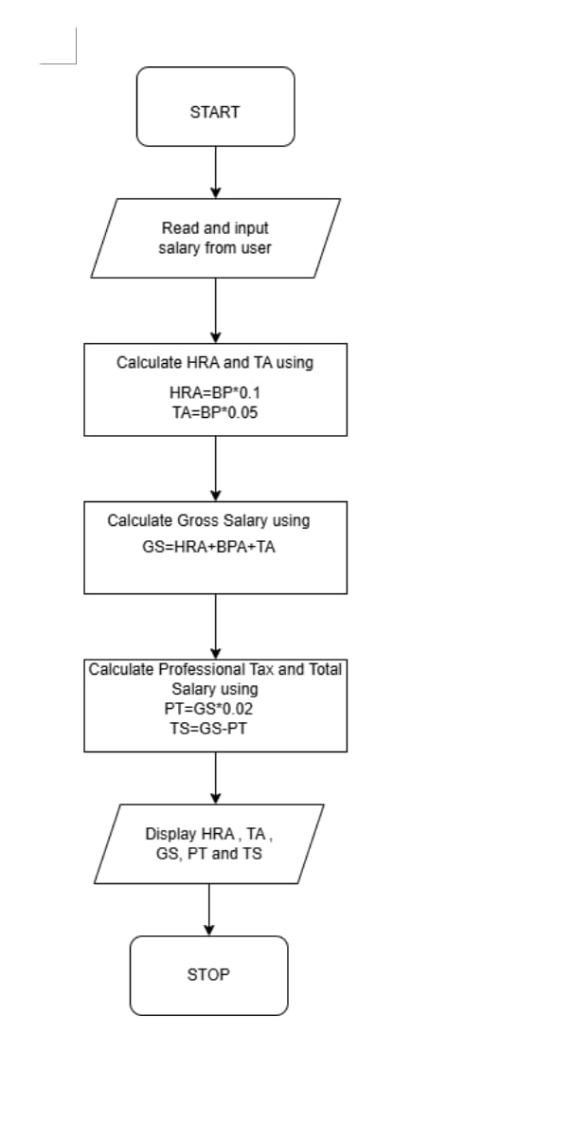

CODE:

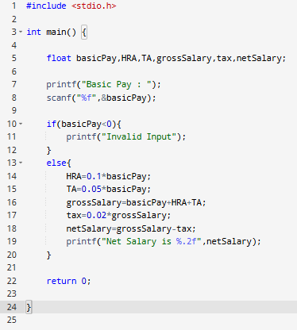

INPUT & OUTPUT:
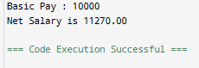

CONCLUSION: Thus, we have learned to write algorithms and to draw its representation in terms of flowchart.

FAQs:
- Describe various symbols and their use in flowchart.
- Difference between Algorithm and Flowchart.

